**Dream Homes Reality**

# Dream Homes Reality

# PREPARATION AND MAINTAINENCE OF ZOHO BOOK

**Introduction**

Have you ever dreamed of owning your perfect home, designed and built to your exact specifications? The idea of a dream house is something that captures the imagination of many, but often feels like an unattainable fantasy. However, with the right tools and resources, turning your dream house into a reality is within reach. ZohoBooks is one such tool that can help you streamline your finances and make the process of building your dream house more efficient.

**What is the objective of Zoho Books?**

Zoho Books is a comprehensive accounting software that is designed to simplify financial management for businesses and individuals alike. Its primary objective is to help users organize their finances, track income and expenses, and make informed decisions that will lead to long-term financial stability. By providing a user-friendly interface and a range of useful features, Zoho Books aims to make financial management accessible to everyone, regardless of their level of expertise.

**Why do we need Zoho Books?**

When it comes to building your dream house, managing your finances effectively is crucial. Without proper financial planning and organization, the construction process can quickly become overwhelming and chaotic. ZohoBooks offers a solution by providing a centralized platform where you can track and manage all your financial transactions, invoices, and expenses. With its intuitive interface and easy-to-use features, ZohoBooks empowers you to have complete control over your finances, helping you stay on top of your budget and make informed decisions every step of the way.

**Problems of Empathy Map and Brainstorming**

When embarking on a construction project, it's important to consider the needs and preferences of everyone involved. Traditional methods such as empathy mapping and brainstorming can be helpful in understanding the requirements of different stakeholders. However, these methods often fall short in effectively capturing and prioritizing their needs. Zoho Books solves this problem by providing a platform where you can store and share information related to the project, ensuring that everyone is on the same page. This eliminates miscommunication and streamlines the decision-making process, ultimately leading to a smoother construction experience.

**Empathy Map**

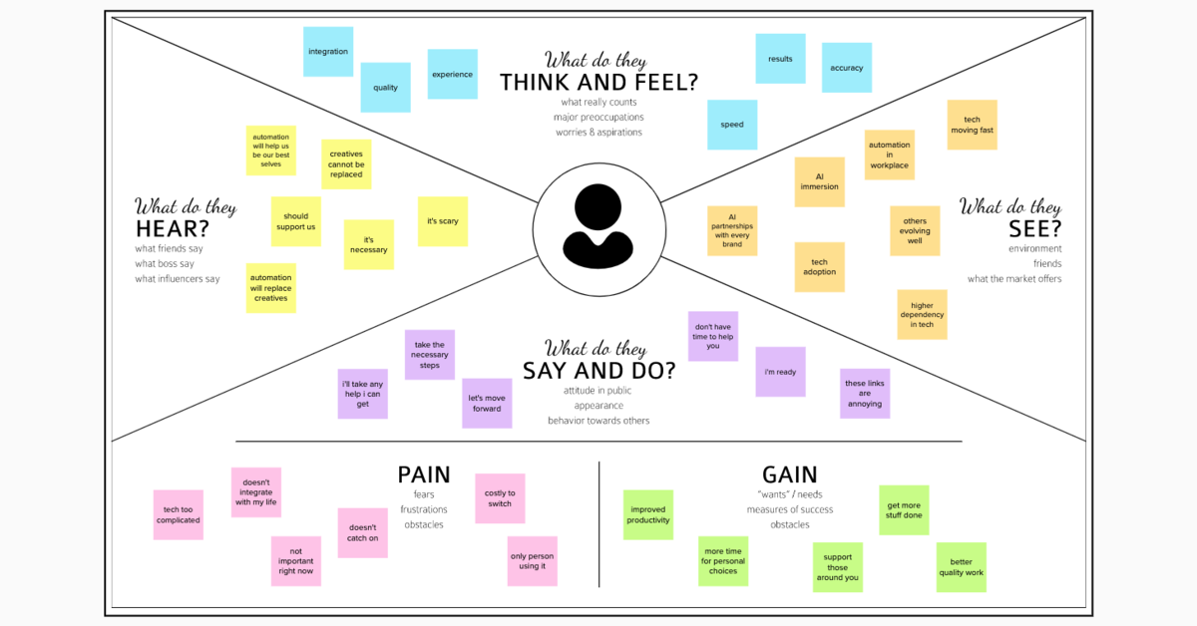

**Brainstorming Map**

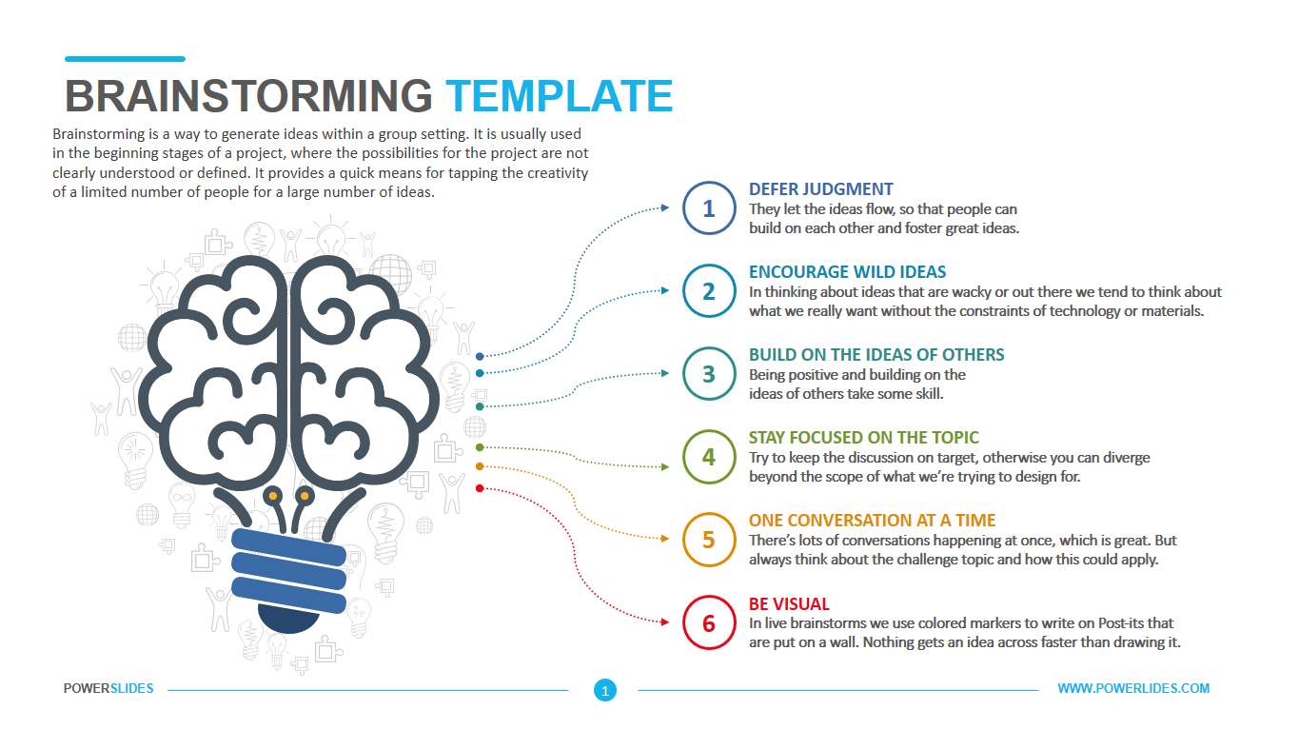

**Features of Zoho Books**

Zoho Books offers a range of features that make it an indispensable tool for managing your finances during the construction of your dream house. Some of its key features include:

1. Invoicing and Expense Tracking: Easily create and send professional invoices, track your expenses, and manage your cash flow.
2. Financial Reports: Generate detailed financial reports that give you a clear picture of your income, expenses, and overall financial health.
3. Time and Expense Tracking: Keep track of the time and expenses associated with your construction project, ensuring that everything is accounted for.
4. Project Management: Organize and manage your construction project by creating tasks, setting deadlines, and assigning responsibilities.
5. Collaboration and Communication: Share information, documents, and updates with your team members, contractors, and suppliers, ensuring effective collaboration throughout the construction process.

**Advantages of Zoho Books**

Using Zoho Books to manage your finances during the construction of your dream house offers several advantages:

1. **Efficiency**: Zoho Books streamlines financial management, saving you time and effort by automating tasks and providing a centralized platform for all your financial information.
2. **Accuracy**: With Zoho Books, you can ensure that your financial records are accurate and up to date, helping you make informed decisions based on reliable data.
3. **Cost Control**: By closely tracking your expenses and monitoring your budget, Zoho Books allows you to maintain better control over costs, preventing overspending and avoiding financial surprises.
4. **Collaboration**: With its collaboration features, Zoho Books facilitates effective communication and collaboration among all stakeholders, ensuring everyone is on the same page throughout the construction process.

**Disadvantages of Zoho Books**

While Zoho Books offers numerous advantages, it's essential to consider potential limitations as well:

1. **Learning Curve**: Initially, using a new accounting software like ZohoBooks may require some time and effort to familiarize yourself with its features and functionality.
2. **Integration**: If you already have an existing accounting system in place, integrating ZohoBooks into your workflow may require additional setup and configuration.
3. **Pricing**: Depending on your needs and the size of your construction project, the cost of using ZohoBooks may vary. It's important to consider your budget and evaluate the pricing structure to ensure it aligns with your requirements.

**CONCULSION**

In conclusion, turning your dream house into a reality requires careful financial management. ZohoBooks offers a comprehensive solution that can help streamline your finances and ensure that your construction project stays on track. With its features, advantages, and user-friendly interface, ZohoBooks is the ideal tool to support you on your journey towards achieving your dream home. So why wait? Start using ZohoBooks today and turn your dream house into a tangible reality!

**Empathy** Is Seeing With eyes of another,

Listening with the ears of Another,

And feeling With the heart of Another.

**THE END**

Creativity is not the domain of one single person.

Through free-association of thoughts and **brainstorming**,

an accidental suggestion can be the best solution.